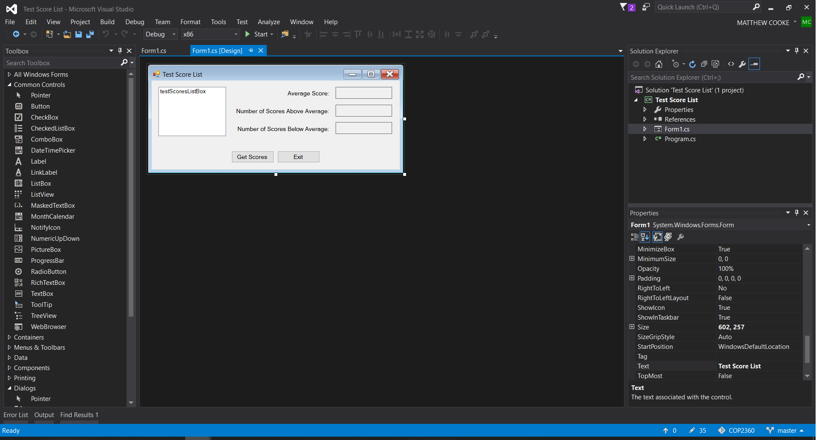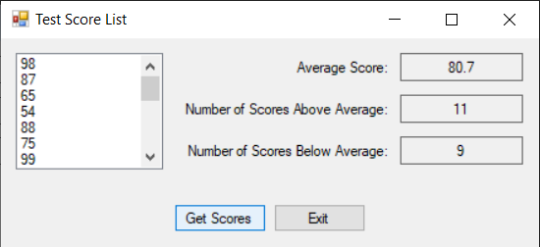

using System;

using System.Collections.Generic;

using System.ComponentModel;

using System.Data;

using System.Drawing;

using System.Linq;

using System.Text;

using System.Windows.Forms;

using System.IO;

namespace Test_Score_List

{

public partial class Form1 : Form

{

public Form1()

{

InitializeComponent();

}

//the readscores method reads the scores from the

//test scores.txt file into the scoreList parameter

private void ReadScores(List<int> scoresList)

{

try

{

//open Testscores.txt file

StreamReader inputFile = File.OpenText("TestScores.txt");

//read the scores into the list

while (!inputFile.EndOfStream)

{

scoresList.Add(int.Parse(inputFile.ReadLine()));

}

//close the file

inputFile.Close();

}

catch(Exception ex)

{

MessageBox.Show(ex.Message);

}

}

//The display scores method disoplays the contents of the

//scoreslist parameter in the list box control

private void DisplayScores(List<int> scoresList)

{

foreach (int score in scoresList)

{

testScoresListBox.Items.Add(score);

}

}

//the Average method returns the average of the values

// in the scoresList Parameter

private double Average(List<int> scoresList)

{

int total = 0; //accumulator

double average; //to hold avg

//calculate the total of the scores

foreach(int score in scoresList)

{

total += score;

}

//calculate the average of the scores

average = (double) total / scoresList.Count;

//return the average

return average;

}

//the Above average method returns the number of above average

//scores in the scorelist

private int AboveAverage(List<int> scoresList)

{

int numAbove = 0; //accumulator

//get the average score

double avg = Average(scoresList);

//count the number of above average scores

foreach(int score in scoresList)

{

if (score > avg)

{

numAbove++;

}

}

// return the number of above average scores

return numAbove;

}

//the Belowaverage method returns the number of below average

//scores in the scorelist

private int BelowAverage(List<int> scoresList)

{

int numBelow = 0; //accumulator

//get the average score

double avg = Average(scoresList);

//count the number of below average scores

foreach (int score in scoresList)

{

if (score < avg)

{

numBelow++;

}

}

// return the number of above average scores

return numBelow;

}

private void getScoresButton_Click(object sender, EventArgs e)

{

double averageScore; //to thold the average scores

int numAboveAverage; //number of above average scores

int numBelowAverage; //number of below average scores

//create a list to hold the scores

List<int> scoresList = new List<int>();

//read the scores from the file into the lsit

ReadScores(scoresList);

// display the scores

DisplayScores(scoresList);

//display the average score

averageScore = Average(scoresList);

AverageLabel.Text = averageScore.ToString("n1");

//display the number of above average scores

numAboveAverage = AboveAverage(scoresList);

aboveAverageLabel.Text = numAboveAverage.ToString();

//display the number of below average scores

numBelowAverage = BelowAverage(scoresList);

belowAverageLabel.Text = numBelowAverage.ToString();

}

private void exitButton_Click(object sender, EventArgs e)

{

//shut the club down

this.Close();

}

}

}